Pointnet++ experimental test instructions

Date: March 4, 2021

1. I have uploaded the code to github, you can find it through the following link.

<https://github.com/Lizhinwafu/LJ_PointNet2_apple_tree>

1. The trained model is in :[log](https://github.com/Lizhinwafu/LJ_PointNet2_apple_tree/tree/main/log)/[part_seg](https://github.com/Lizhinwafu/LJ_PointNet2_apple_tree/tree/main/log/part_seg)/[pointnet2_part_seg_msg](https://github.com/Lizhinwafu/LJ_PointNet2_apple_tree/tree/main/log/part_seg/pointnet2_part_seg_msg)/**checkpoints**/

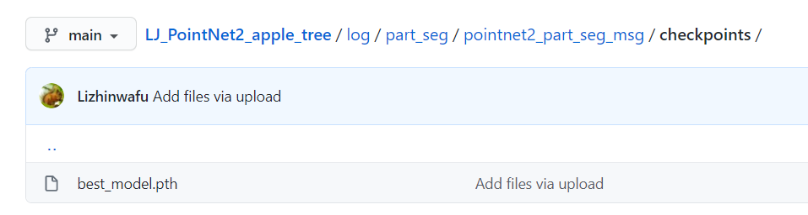

model: best_model.pth

model size: 19.9MB

epoch=10000

training data: tree1, tree2, … tree30

1. If you want to test, you can run the following command, and the test results are in the output_plant folder.

python test_partseg_plant.py --batch_size 1 --log_dir pointnet2_part_seg_msg



1. The default test data is tree31, tree32,tree33; if you want to test other data, you can modify data_utils/PlantNetDataLoader.py—Line 87

And you can choose tree31, tree32, tree33, tree34……tree42.

1. The test results can be viewed in MeshLab.